# > # Pg526#10.65

> h<-45;

> totTPG<-c(42.89, 53.91, 48.55, 47.90, 47.73, 46.61, 40.45, 39.65, 38.65, 37.95, 36.80, 35.95, 35.09, 35.04, 34.95, 33.45, 28.99, 27.45);

> # Test of normality:

> qqnorm(totTPG);qqline(totTPG);

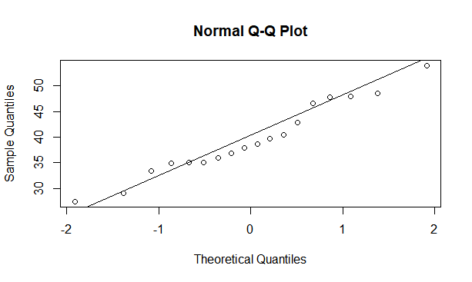

Conclusion: From the plot we conclude normality since, the extremities tend to stay along the overall linear trend.

> # Calculation of the Test Statistics, t

> n<-length(totTPG);

> y<-mean(totTPG);y

[1] 39.55611

> s<-sqrt(var(totTPG));s

[1] 7.137642

> t<-(y-h)*sqrt(n)/s;t

[1] -3.235868

> # Determination of the rejection region

> rr<-qt(0.05,n-1);rr

[1] -1.739607

> # Calculation of the p-value, p

> p<-pt(t,n-1);p

[1] 0.002428782